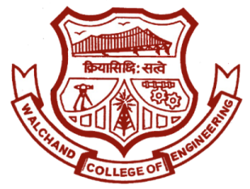

WALCHAND COLLEGE OF ENGINEERING, SANGLI

**ELESA**

**ELECTRONICS ENGINEERING STUDENTS’ ASSOCIATION**

DATE:

To,

Dr. B. G. Patil,

Dean Students Welfare,

WCE, Sangli.

SUBJECT: Regarding permission for organizing mega event ‘ELECTROVERT’ on 5th and 6th October, 2019 and campaigning of it.

Respected Sir,

On 5th and 6th October, ELESA is planning to organize a two day-event **‘ELECTROVERT’**. This event will comprise of ten different sub-events. It is a state level technical event, so we expect huge response as before.

That is why we urge you to grant permission for conducting this event. Also grant us the permission for the campaigning of our event. For campaigning, we would be requiring a counter, displaying our poster on the notice board and announcements in the classrooms.

ELECTROVERT comprises of many different technical competitions related to the different engineering fields. It will surely help the students in not only developing their technical skills, but also in dynamically shaping their personalities.

Also, we assure you that our presence will not cause any hindrance to the academic works of the college.

Yours sincerely,

Approved by:

**HOD,**

**Dept. Of Electronics**

Dr. B. G. Patil

**Staff Advisor**

Prof. R. G. Mevekari

**President**

Ajit Attarde

**Vice-President**

Vishal Narkhede

**Doodle & A.R.O.**

Dhanraj Bhosale

**Event Director**

Tanvi Magdum

Swati Pawar

**Technical Director**

Vinod Patil

**Club Service Director**

Harshad Ahale

**Aptitude Developer**

Shubhashri Kumbhar

**Editor**

Pranav Gosavi

**Web Developer**

Shivdeep Bisurkar

**Treasurer**

Abhishek Gokhale

**Content Developer**

Amruta Shendure

Email: [walchand.elesa@gmail.com](mailto:walchand.elesa@gmail.com) Website: [www.elesa.co.in](http://www.elesa.co.in)

Dr. B. G. Patil

H. O. D.

Eln. department

Mr. Ajit Attarde

President

ELESA

Mr. R. G. Mevekari

Staff adviser

ELESA

Dr. B. G. Patil

Dean Student welfare

WCE Sangli

Dr. P. G. Sonavane,

Director,

WCE Sangli.